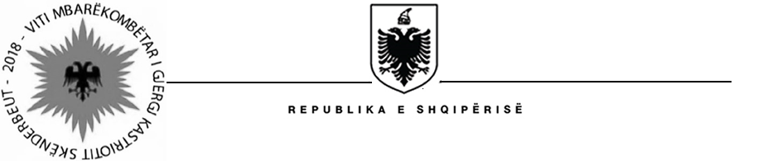

MINISTRY OF AGRICULTURE AND RURAL DEVELOPMENT
SECRETARY GENERAL

Contract Award
Project name: Water Resources and Irrigation Project
Country: Albania
Project number: P121186
Loan number: 8211 – AL
Procurement method: CQ (Consultant’s Qualifications)

Contract Reference No: MAFCP/CS/005a
Scope of Contract: “Supervisory Services for Rehabilitation Works of Murriz Thana Irrigation Scheme Krutja (V1 & V2)”
Duration of Contract: 8 months (including 12 months Defect Liability Period)
Contract Signature Date: 31 July, 2018
Evaluation Currency: ALL – Albanian Lek

Awarded Consultant/Firm:

Name: JV “EN-SU MUHENDiSLiK MUSAViRLiK” Ltd Sti & “GR Albania” Sh.p.k (Turkey & Albania)
Address: Rr. “Sami Frasheri”, Pall. Moskat, 1019, Tirana, Albania
Final Score: 90.45
Final Evaluation price (in evaluation currency): EUR 149,153 (Excluded VAT)
Final ranking: 1
Final negotiated price (in evaluation currency): EUR 149,153 (Excluded VAT)

Evaluated Consultant (s)/Firm(s):
Name: SWS Consulting Engineering & TECHNITAL
Address: Via Marco Marulo, 87/B, 00143 Rome-ITALY
Via Cassano D’Adda 27/1, 20139 Milano-Italy
Final score: 86.37
Final ranking: 3

Name: CES Consulting Engineers.
Address: Salzgitter GmbH, Nordstrasse 23, 38106 Braunschweig GERMANY
Final score: 87.57
Final ranking: 2

Name: Mahab Ghodss Consulting Engineering Company, Private Joint Stock
Address: 16 Takharestan St., Shahid Vahid Dastgerdy Ave., Tehran, Iran
Final score: 76.30
Final ranking: 7

Name: Societa Italiana di Monitoraggio SpA in JV with Abcons ltd
Address: Via Ticino, 6 – 00198 Roma, Italy
Final score: 84.33
Final ranking: 5

Name: “UNITEC-STUDIO” LTD
Address: Rr. “R. Collaku”, P17, Ap. 249,
Final score: 41.00
Final ranking: 12

Name: HYDROMENT Consulting Engineers (Greece) in association with iC consulenten Ziviltechniker GmbH (Austria)
Final score: 50.50
Final ranking: 11

Name: CACG Compagnie d’Amenagement des Coteaux de Gascogne & C.E.C Group Civil Engineering Consultants
Address: Chemin de Lalette – CS 50449 65004 Tarbes Cedex, France
Final score: 67.52
Final ranking: 9

Name: HYDROARCH S.r.l. in association with C&M Consulting & Management Albania
Address: Via Gian Luca Squarcialupo, 10 – 00162 Rome, Italy
Final score: 53.50
Final ranking: 10

Name: CONSULTING ENGINEERING CENTER & GJEOKONSULT & CO ltd
Address: Building No. 30, Ma’rouf Rasati street, Shmeisani, Amman – Jordan
Pallati Mehillaj, Kthesa e Kamzes, Kashar, Tirane
Final score: 80.72
Final ranking: 6

Name: GR ALBANIA Consulting Company & EN-SU Engineering & Consultancy
Address: Rr. “Sami Frasheri”, Pall. Moskat, 1019, Tirana, Albania
Final score: 90.45
Final ranking: 1

Name: ACE CONSULTING ENGINEERS MOHARRAM.BAKHOUM
Address: 6, Al-Koroum Street, Dokki, Gizza-Egypt
Final score: 73.37
Final ranking: 8

Name: JV: NET Engineering S.p.A. (Leader) & Centro Consulenze Consulting Center S.r.l. Address: Centro Direzionale “Le Torri”, Via Squero 12, 35043 (Padova), ItalyMonselice
Final score: 84.58
Final ranking: 4

