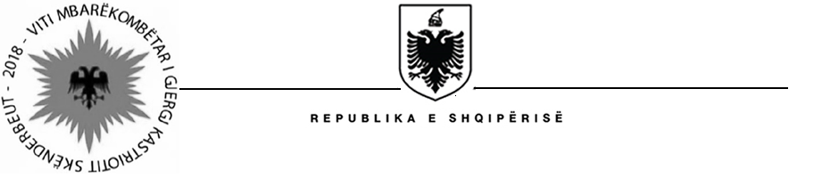

MINISTRY OF AGRICULTURE AND RURAL DEVELOPMENT
SECRETARY GENERAL

Contract Award
Project name: Water Resources and Irrigation Project
Country: Albania
Project number: P121186
Loan number: 8211 – AL
Procurement method: CQ (Consultant’s Qualifications)

Contract Reference No: WRIP/CS/QC/006
Scope of Contract: “Monitoring & Evaluation Consultancy end Project Survey Final for Component 3 and Interim for Component 1, 2 and 4” (Ref. No. WRIP/CS/CQ/006).
Duration of Contract: 4.5 months (August 2018 - December 2018)
Contract Signature Date: 31 July, 2018
Evaluation Currency: ALL – Albanian Lek

Awarded Consultant/Firm:

Name: “IDRA Research & Consulting (Albania) & Institute of Economies Studies and Knowledge Transfer.”
Address: Rr. “Siri Kodra”, Nd. 94, H. 5, Ap. 50, PO Box. 1730, Tirana, ALBANIA
Final Score: 91.98
Final Evaluation price (in evaluation currency): ALL 4,988,500 (Excluded VAT)
Final ranking: 1
Final negotiated price (in evaluation currency): ALL 4,988,500 (Excluded VAT)

Short List Evaluated Consultant (s)/Firm(s):
Name: AULEDA (Albania)
Address: L. “Isa Boletini”, Rr. “Vlore-Skele”, K. III, prane Bankes IntesaSanPaolo,
Vlore, ALBANIA
Final score: 69.15
Final ranking: 3

Name: Urban Research Institute (URI) (Albania)
Address: Rr. “Asim Vokshi”, Nd. 14, H.11, Ap. 56, Tirana, ALBANIA
Final score: 91.12
Final ranking: 2

Consultant submitted EoI (s)/Firm(s):
Name: “Tjeter Vizion”
Address: L. “Aqif Pasha”, Rr. “Ali Arapi”, Elbasan ALBANIA
Final score: Not qualified
Final ranking: Not qualified

