Projekti IPA 2013
Restructuring and Strengthening of the Food Safety and Veterinary Laboratory Network in Albania

Closing event:
This project has been contributing for duration of more than 3 years, for the reinforcement of our national capacities in the Ministry of Agriculture and Rural Development, Institute of Food Safety and Veterinary and National Food Authority to ensure improved levels of food safety over the whole food chain.
The project had 3 main action components to further strengthen and make more efficient use of laboratory staff and resources
- Eliminating overlaps and duplications of responsibilities of different categories of government laboratories, while moving progressively to adoption and implementation of EU controls and analytic methods relating to food safety, detection and control of diseases of plants and animals and quality standards;
- Increasing the efficiency and international acceptance of tests performed by Government laboratories (through development of training plans and delivery of trainings, and development of new analytical methods). Significant support was allocated to preparing accreditation strategies and supporting preparation and application by pesticide and other FSVI laboratories for national accreditation to ISO standard 17025, as required by EU laws applying to foods exported to the EU.
- Developing specifications and facilitating contract and acceptance completions of the supply contracts related to laboratory equipment for FSVI and 3 Regional laboratories of NFA (Shkodra, Korca and Gjirokastra) financed through EU financial support to a value of 1.9 million €.
Improving and strengthening food safety in Albania is one of the government’s principal priorities. In this frame, it is important that to the consumers is offered safe food and at all levels of the food chain from farm to table must be adequately regulated and controlled by our institutions. .

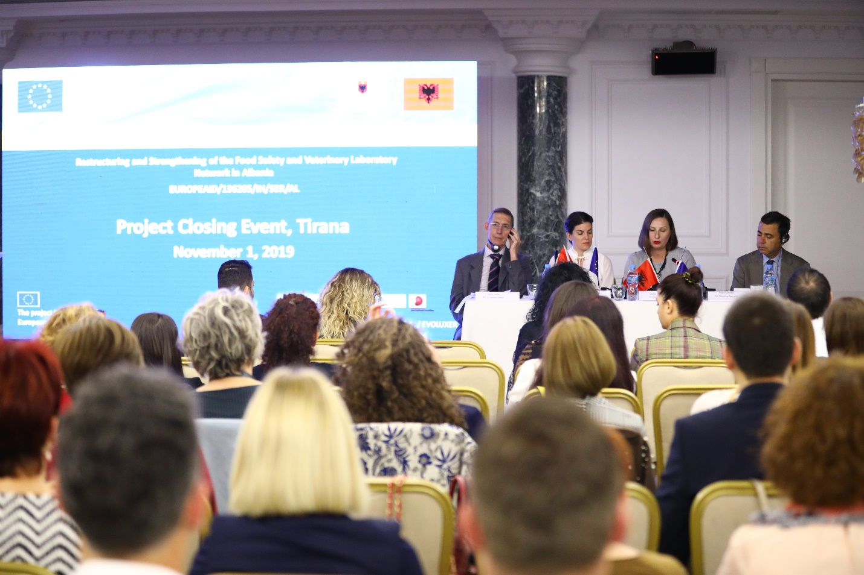
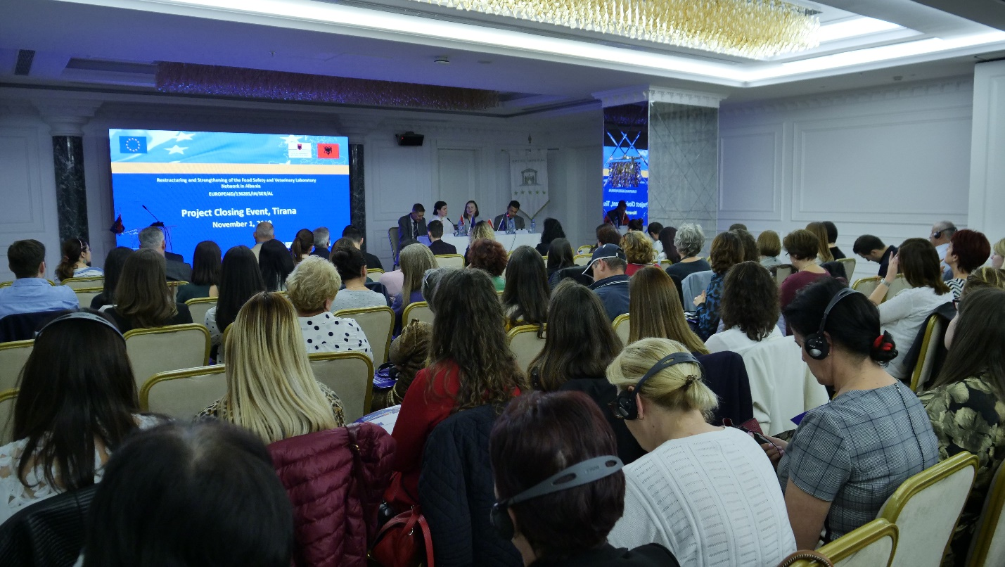



Some Key Project data

Contract Title: Restructuring and Strengthening of the Food Safety and Veterinary Laboratory Network in Albania

Project Location: Tirana, Albania
Project duration: 40 months
Project Implemented by: Consortium by PLANET S.A./PRYSMA S.A./EVOLUXER S.L/SARGA/ Universidad Complutense de Madrid
Project starting date: July 4th, 2016
Project end date: November 3rd, 2016

Project Overall Objective:
The overall objective of the project is to facilitate and support the national administrative capacities to ensure improved levels of food safety over the whole food chain.
Project Specific Objectives:
- The setup of a cost-efficient laboratory network capable of providing reliable and timely information on the safety of marketed food and animal health.
- The enhancement of the capacity of the laboratory network to carry out monitoring and analysis of food and feed products with specific reference in the fields of pesticide residues monitoring, microbiological diagnostics in food and feed, food quality standards, animal diseases, in accordance with improved national standards.
Project Key Results:
Result 1: A reorganized laboratory network in accordance with a clear legal and institutional framework is functional and cost-efficient.
Result 2: The analytic and diagnostic capacity of the laboratory system is enhanced due to training of staff in the application of modern methods and techniques
Project Contracting Authority:
The General Directorate of Financing and Contracting of EU, World Bank and other Donor Funds / Central Finance and Contracting Unit (CFCU), Ministry of Finance and Economy

Project Key Beneficiaries:
Main project Beneficiary:
- the Ministry of Agriculture and Rural Development (MARD)
Other Beneficiaries:
- the Food Safety and Veterinary Institute (FSVI) in Tirana
- the National Food Authority (NFA) in Tirana and relevant local laboratories

