Projekti IPESA
The SAP process
The 1st Working Group Workshop

One of priorities of the IPESA project is to complete the critical need for a Strategic action plan (SAP) for ANES that will include appropriate commitment by Government to provide the necessary financial and other resources to improve the capacity of the advisors.
This is a necessary step not only to ensure an effectively working extension service but also to be an important strategic roadmap for progress on Agricultural Knowledge Information System -AKIS & Farm Advisory System - FAS, as these will be contributing elements in relation to Albania’s accession negotiations Chapter 11 (Agri& RD) and Chapter 12 (Food safety, veterinary, phytosanitary), also Ch.26 (Education) & Ch.27 (Environment).
After discussions with MARD officilas about the Strategy, a meeting with the officials of the Directory of Policy, Prioritization and Development of Prime Ministry, was held on the 15th January 2019. It was agreed to develop a Strategic Action Plan (SAP) for 3 years, to include activities, sub activities, indicators, budget, and its relation to Intra- Sectorial Agricultural Rural Development strategy (ISARD).
The SAP process was launched by the Minister for Agriculture and Rural Development at a workshop organised by MARD (supported by IPESA) on 28th February 2019 attended by around 50 stakeholders. The workshop explored and outlined the key issues to be covered in the SAP process and the proposed timeline. Four ad hoc working groups are established – each relating to one of the four chapters of the proposed table of contents of the SAP.
The 1st Working Group Workshop (Context and Operating Environment) was held on 17 April 2019, in the MARD and attended by a range of stakeholders.
The first SAP WG meeting managed to deliver fruitful discussion among different stakeholders – from public, NGOs and private sector.
Some pictures from the above mentioned activities:
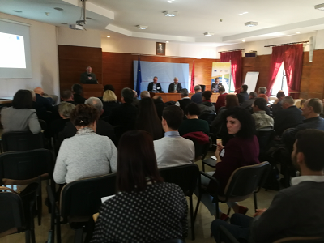
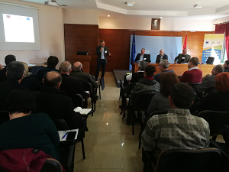
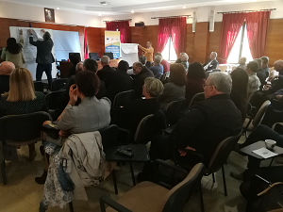
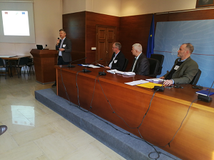

The 2ndWorking Groups 2 & 3(Identification of target groups operating environment -Group 2 &Goals, objectives, strategic actions and performance indicators – Group 3) was held on 3 July 2019, in the MARD and attended by a wider range of stakeholders. The main conclusions, collected from the groups can be summarized as following:
- Regarding meat and milk producers it is very important to focus on animal and plant (feed) quality and appropriate use of veterinary knowledge & medicines (reportage from veterinary/farmer), costs and marketing of products;
- The main criteria for target group selection for ANES advice are (i) the herd size (from 5-30 cows, tax registered, market oriented and ideally advise through discussion groups (ii) business cooperation groups, (iii) > 50 cows should advise through 1:1 approach.
- Identification of the main milk & meat farmers/groups to target for ANES advice such as (i) the younger generation has reducing interest in farming, therefore any training must be interesting and very relevant to making a successful and viable career in farming, (ii) Start-up/new farmers should be certified (but not clear about certified for what) (iii) main target should be younger farmers and new start-up farmers (over 55 years should NOT be main priority) (iv)Farmer cooperative/group members should have roughly similar numbers of animals each (i.e. not big differences in scale.
- Their main knowledge & improvement needs are (i) seedling production and quality, soil/fertility testing, financing/funding opportunities (ii) Digitalisation (iii) new technologies, including integration production techniques (iv) post-harvest infrastructure and systems, & marketing (v) financial and business planning;
- The main criteria for target group selection for ANES advice should be (i) Only those farmers who are integrated with/supplying the market (ii) special focus on women farmers (iii) special focus on farmers applying for support schemes;
- Identification of the main V&F farmers/groups to target for ANES advice are (i) only those farmers who are integrated with/supplying the market (including those doing small scale processing) (ii) younger farmers;
- Regarding wider rural businesses & rural dwellers/entrepreneurs, their main knowledge & improvement needs (i) to increase the market and business knowledge and business plan models (ii) include the focus on food safety (iii) more information and training for support schemes;
- the main criteria for target group selection for ANES advice should be (i) legal persons (registered) (ii) farmer groups/cooperatives (iii) focus on young farmers and women (iv) export and processing oriented farmers, and start-up farmers;
- Identification of the main V&F farmers/groups to target for ANES advice, and also the knowledge for the market & marketing.

